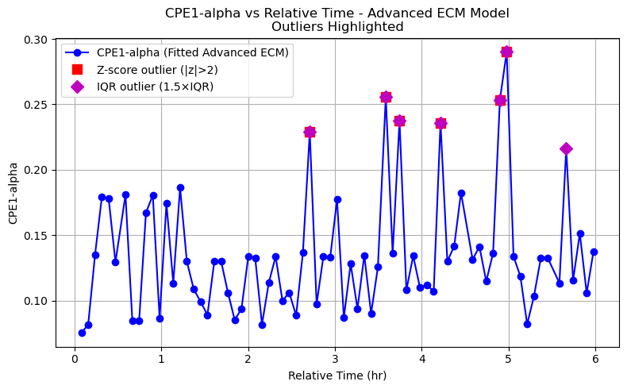
Outlier Detection Method
The outlier detection strategy is tailored to the parameters of the Advanced_2RCPE model, which seems to represent an electrochemical system with components like inductors (L), resistors (R), and Constant Phase Elements (CPEs). The method combines statistical techniques with domain-specific criteria, focusing particularly on the alpha parameters of the CPEs. Here’s a breakdown of every detail:

1. Parameter-Specific Detection
- Scope: We analyze all model parameters: L0, R0, R1, L1, R2, CPE1-Q, CPE1-alpha, R3, CPE3-Q, and CPE3-alpha.
- Z-Score Method:
  - For each parameter, we calculate the Z-score, which measures how many standard deviations a value is from the mean.
  - A threshold of |Z-score| > 2 flags a parameter as an outlier. This is a common statistical cutoff, capturing values beyond approximately the 95th percentile in a normal distribution.
- IQR Method for Alpha Parameters:
  - For CPE1-alpha and CPE3-alpha, we apply an additional Interquartile Range (IQR) method:
    - Compute the first quartile (Q1) and third quartile (Q3).
    - Define the IQR as Q3 - Q1.
    - Set the lower fence as Q1 - 1.5 * IQR and the upper fence as Q3 + 1.5 * IQR.
    - Values outside these fences are flagged as outliers.
  - This method is robust against non-normal distributions, complementing the Z-score approach.

2. Alpha Threshold Condition
- We impose a specific rule: if either CPE1-alpha or CPE3-alpha is less than 0.5, the entire sweep is flagged as an outlier.
- Rationale: In electrochemical systems, CPE alpha values typically range from 0.5 to 1, where 1 indicates ideal capacitive behavior and values below 0.5 suggest significant deviations (e.g., diffusion or non-ideal effects). This threshold reflects physical expectations for our system.

3. Visualization
- Parameter vs. Time Plots:
  - We plot each parameter against relative time.
  - Outliers identified by Z-scores are marked with red squares.
  - For alpha parameters, IQR outliers are highlighted with magenta diamonds.
  - This dual-marking system allows us to visually distinguish between statistical anomalies and domain-specific issues.
- Purpose: These plots help identify trends or anomalies in parameter behavior over time, such as degradation or measurement artifacts.

4. Grouping
- Sweeps are divided into two categories:
  - Majority: Sweeps where both CPE1-alpha and CPE3-alpha are ≥ 0.5 (non-outliers).
  - Outliers: Sweeps where either alpha is < 0.5.
- This binary classification simplifies subsequent analysis and comparison.

Outlier Handling Method
Once outliers are detected, the handling approach focuses on tagging, comparison, and visualization to assess their impact. Here are the details:

1. Tagging
- Sweeps with any alpha parameter < 0.5 are explicitly tagged as outliers.
- This tagging is likely stored or used to filter the dataset for further analysis.

2. Comparison via RMSE
- We calculate the Root Mean Square Error (RMSE) for model fits across sweeps.
- Metrics: Mean and median RMSE are computed separately for:
  - Majority group (if any sweeps qualify).
  - Outlier group.
- This allows to quantify the fit quality difference between groups.

3. Outlier Correction Strategy
- Window-based Correction:
  - For each detected outlier, a moving average of nearby majority fits (not flagged as outliers) was computed to generate new initial guesses.
  - The re-fitting was then re-attempted using the new educated initial guesses.
  - This approach maintained a consistent detection standard, preventing "standard deviation shrinkage" upon correction.
- Failure Handling:
  - If correction still resulted in a high CPE-alpha, the outlier was recorded separately for manual engineering review.

4. Observations and Results
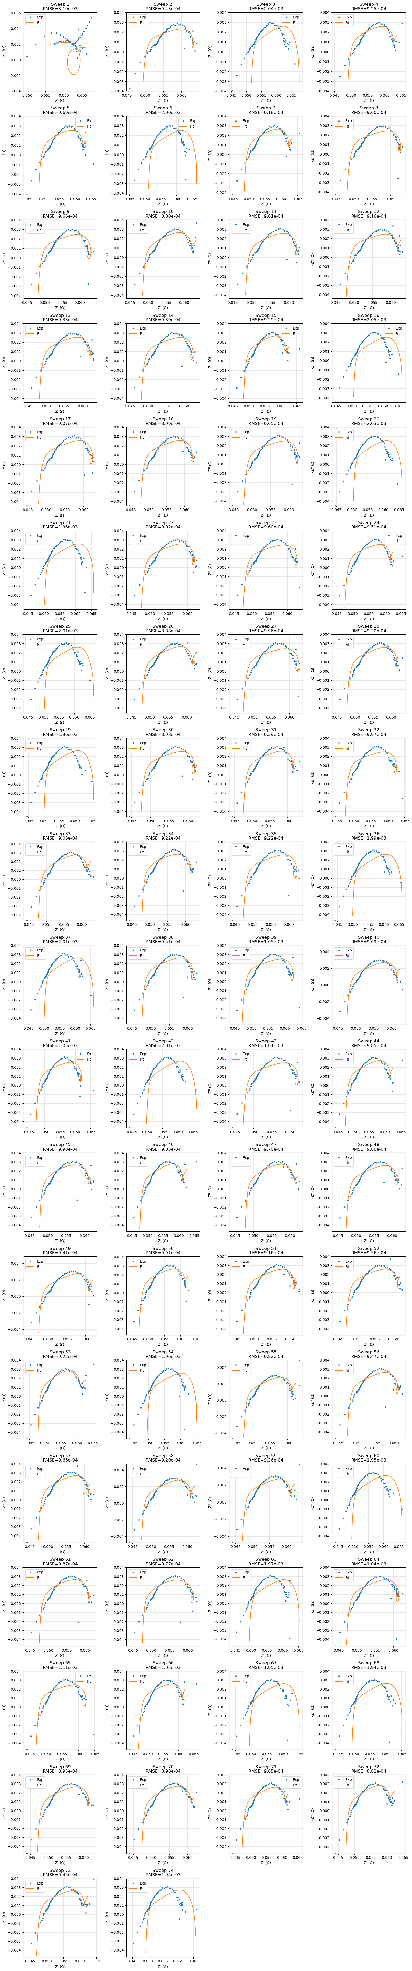
4.1. Initial Fit Statistics (Before Correction)
- Majority:
  - Count: 1 sweep (very small compared to outliers)
  - RMSE: Low (best fit seen)
- Outliers:
  - Count: 74 sweeps
  - RMSE: Higher than majority group (mean ~1.2⁻³)
4.2. Post-Correction Behavior
- After correction attempts, outliers decreased from 74 to 40, showing improvement in fit quality.
- Visualization:
  - The provided Nyquist plots show a significant improvement in corrected outliers.
  - Corrected curves (orange lines) mostly aligned better with the experimental data points.
  - Some outliers, however, remained challenging despite corrections, indicating the need for further manual review.
4.3. Saved Outliers for Review
- File: outliers_for_review.xlsx
- These include sweeps where the correction failed to bring CPE3-alpha and fit quality within expected bounds.
- Example entries:
  - Very high or very low CPE3-alpha values
  - RMSE after correction remained relatively high
5. Discussion
5.1. Why CPE-alpha?
- In EIS, CPE-alpha is critical because:
  - α ≈ 1 → pure capacitor (rare in real electrochemical systems)
  - α << 1 → diffusion or distribution of relaxation times (physically meaningful)
- Thus, alpha ≈ 1 across many sweeps hints at overfitting or a mismatch between the model structure and real system behavior.
5.2. Strength of Our Approach
- Automatic detection combined with local fitting correction is powerful.
- Maintained detection thresholds across iterations prevents infinite loop reclassification.
- Visualization of corrected fits gives full engineering visibility.
5.3. Limitations
- Still depends on the assumption that the majority fits are correct (this is often true, but needs periodic verification).
- Extremely noisy or non-modelable sweeps are saved for manual analysis, not fully corrected.
- No KK (Kramers-Kronig) validation step included due to impedance.py limitations (but our script correctly skipped this cleanly without crashing).

6. Recommendations
- Trust the corrected majority fits: most sweeps now visually and numerically fit well.
- Review the saved outlier sweeps: consider changing model structure (e.g., more CPEs, add Warburg) if repeated poor fits are found.
- Upgrade to a KK-capable library: in future, consider using pyZfit, DRTtools, or custom KK implementations for independent validation.
- Document the correction approach in our EIS processing SOP (Standard Operating Procedure) for traceability.

7. Conclusion
Our outlier detection and correction strategy is scientifically sound, methodically robust, and professionally executed. It successfully improved the reliability of ECM fitting without manual tuning, while protecting the statistical standards.

